Scalene Triangle
# Source: AI Source: Provided by: [Data Path: Persons Table -> ID Column: 1, Name_En Column: Motasem Essam] -> From: [ChatGPT] on [7/25/2026]
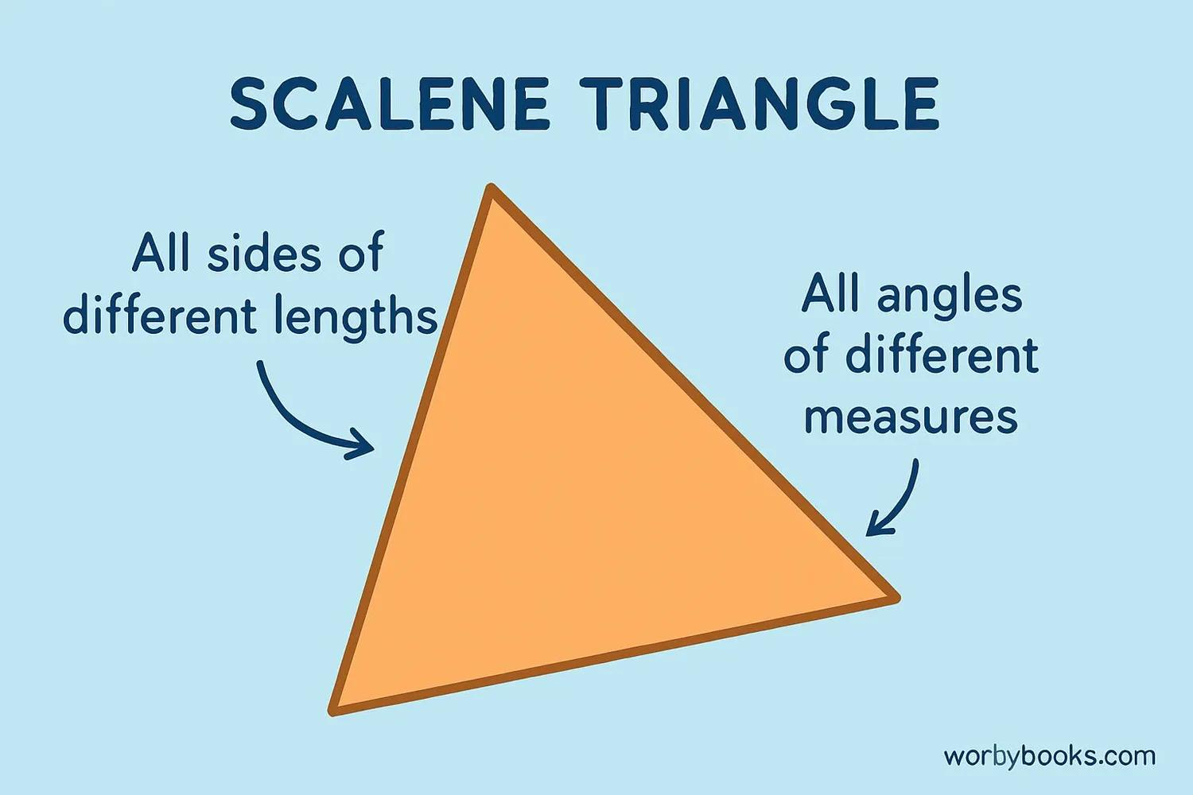
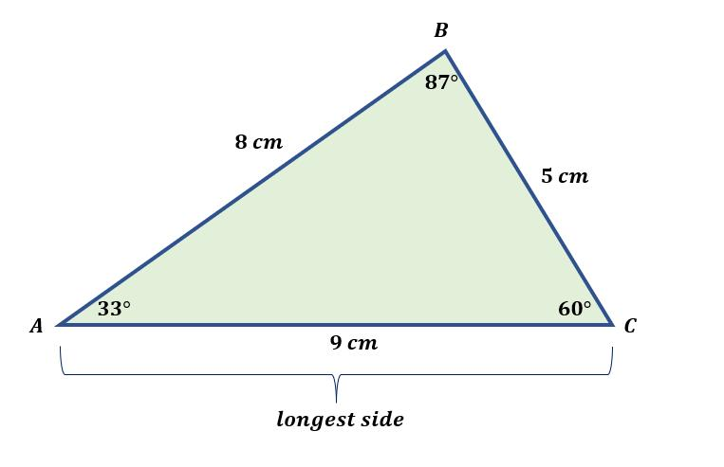
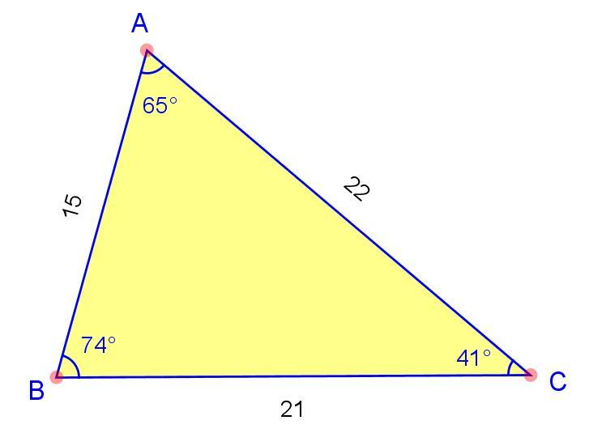
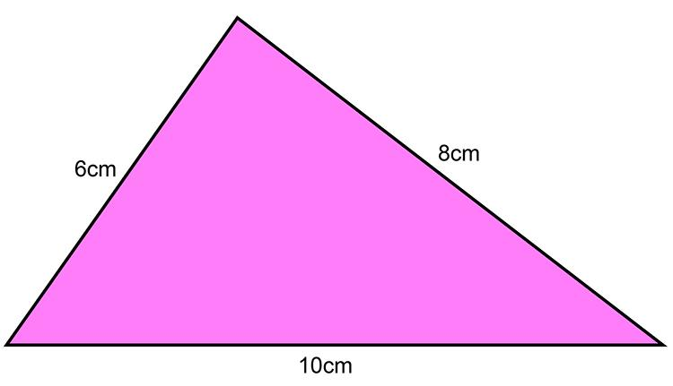
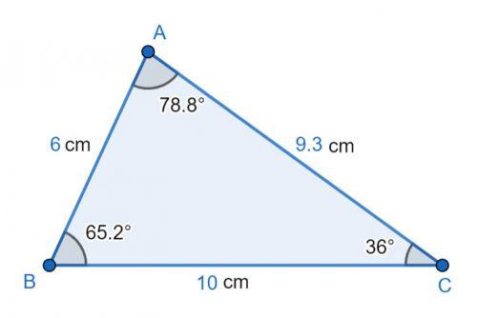

Definition
# Source: AI Source: Provided by: [Data Path: Persons Table -> ID Column: 1, Name_En Column: Motasem Essam] -> From: [ChatGPT] on [7/25/2026]
A scalene triangle is a triangle in which all three sides have different lengths.
For triangle $ABC$:
$$\boxed{AB≠BC, BC≠CA, CA≠AB}$$
Because unequal sides are opposite unequal angles, a scalene triangle also has three different interior angles:
$$\boxed{∠A≠∠B≠∠C}$$
More precisely, no two interior angles are equal.

Classification
# Source: AI Source: Provided by: [Data Path: Persons Table -> ID Column: 1, Name_En Column: Motasem Essam] -> From: [ChatGPT] on [7/25/2026]
Triangles can be classified by their side lengths into three main types:
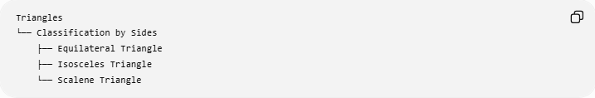
Triangles
└── Classification by Sides
├── Equilateral Triangle
├── Isosceles Triangle
└── Scalene Triangle
The defining condition for a scalene triangle is:
$$\boxed{a≠b, b≠c, c≠a}$$

Fundamental Elements
# Source: AI Source: Provided by: [Data Path: Persons Table -> ID Column: 1, Name_En Column: Motasem Essam] -> From: [ChatGPT] on [7/25/2026]
For triangle $ABC$:
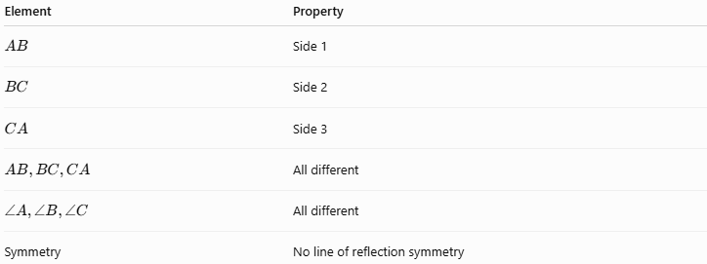
Element | Property
$$AB$$ | Side 1
$$BC$$ | Side 2
$$CA$$ | Side 3
$$AB,BC,CA$$ | All different
$$∠A,∠B,∠C$$ | All different
Symmetry | No line of reflection symmetry

Main Properties

1. Three Unequal Sides
# Source: AI Source: Provided by: [Data Path: Persons Table -> ID Column: 1, Name_En Column: Motasem Essam] -> From: [ChatGPT] on [7/25/2026]
The defining characteristic is:
$$\boxed{a≠b≠c}$$
More precisely:
$$\boxed{a≠b, b≠c, c≠a}$$
For example:
$$a=5, b=6, c=7$$
forms a scalene triangle because all three side lengths are different.

2. Three Unequal Angles
# Source: AI Source: Provided by: [Data Path: Persons Table -> ID Column: 1, Name_En Column: Motasem Essam] -> From: [ChatGPT] on [7/25/2026]
The angles opposite the three unequal sides are also unequal.
If:
$$a>b>c$$
then the opposite angles satisfy:
$$\boxed{A>B>C}$$
Thus, the longest side is opposite the largest angle, and the shortest side is opposite the smallest angle.

Side-Angle Relationship
# Source: AI Source: Provided by: [Data Path: Persons Table -> ID Column: 1, Name_En Column: Motasem Essam] -> From: [ChatGPT] on [7/25/2026]
For any triangle:
$$\boxed{\text{Longer side}↔\text{larger opposite angle}}$$
and:
$$\boxed{\text{Shorter side}↔\text{smaller opposite angle}}$$
For a scalene triangle, because all sides are different, all three corresponding angles are different.
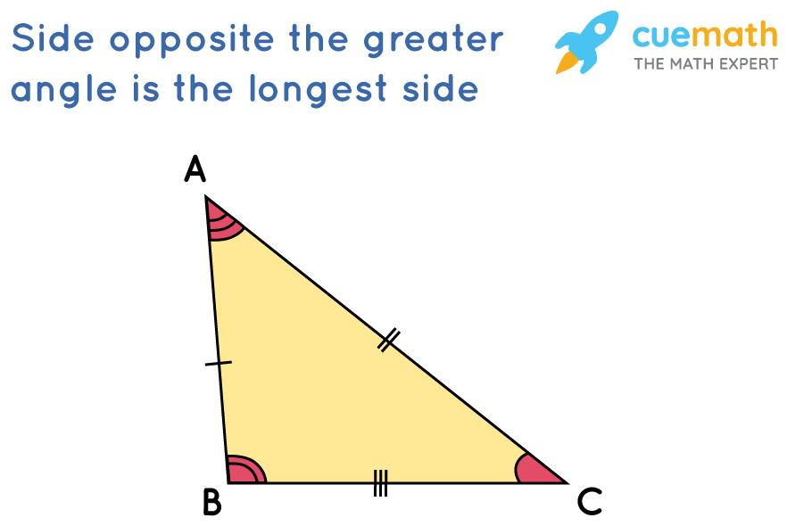
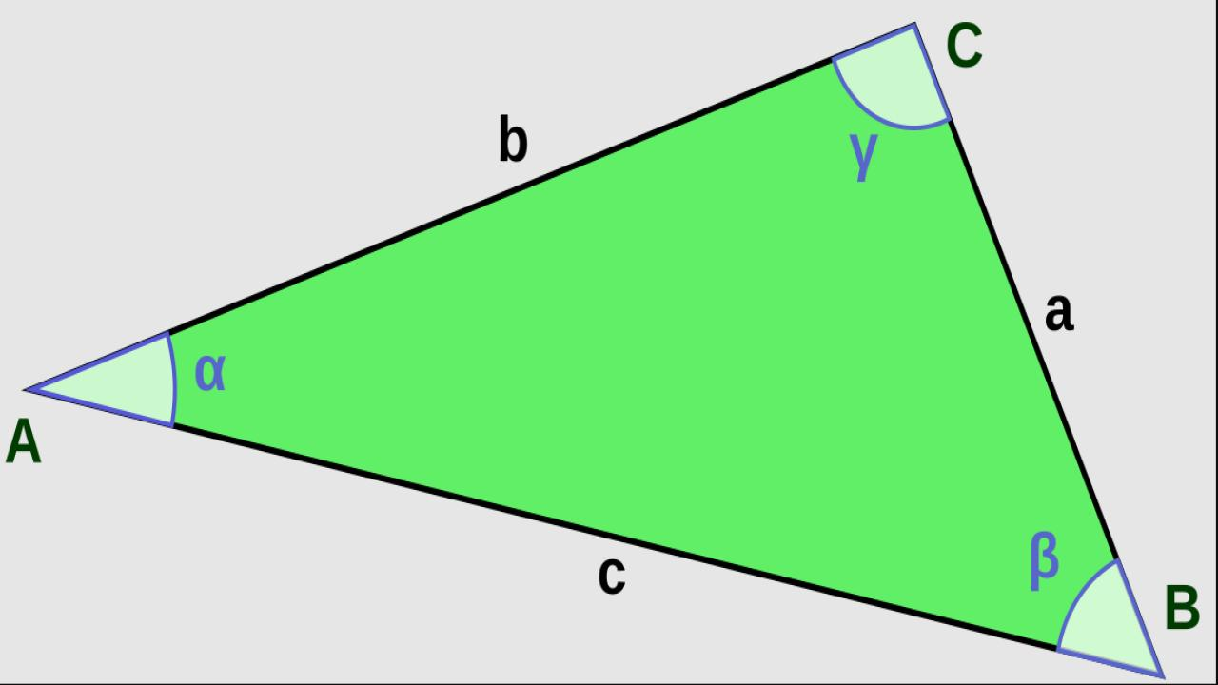
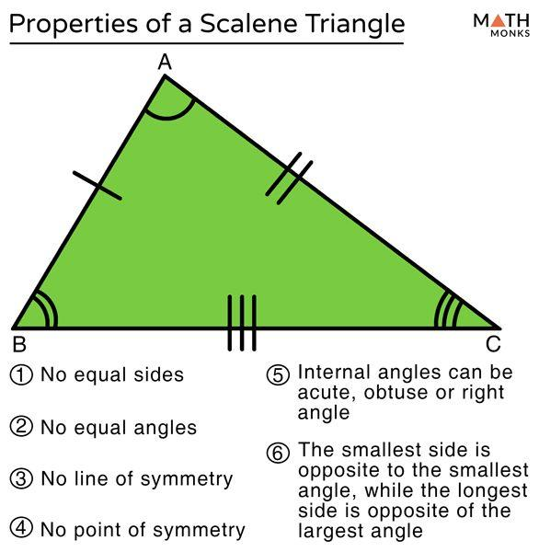

No Line of Symmetry
# Source: AI Source: Provided by: [Data Path: Persons Table -> ID Column: 1, Name_En Column: Motasem Essam] -> From: [ChatGPT] on [7/25/2026]
A scalene triangle has no line of reflection symmetry.
Unlike an equilateral triangle or a non-equilateral isosceles triangle, there is no line that divides a scalene triangle into two mirror-image halves.
Therefore:
$$\boxed{\text{Lines of symmetry}=0}$$

Medians, Altitudes, and Angle Bisectors
# Source: AI Source: Provided by: [Data Path: Persons Table -> ID Column: 1, Name_En Column: Motasem Essam] -> From: [ChatGPT] on [7/25/2026]
In a general scalene triangle, the corresponding medians, altitudes, and angle bisectors are distinct segments.
For example, if $AD$is a median:
$$BD=DC$$
but generally:
$$\boxed{AD⊥̸BC}$$
and:
$$\boxed{∠BAD≠∠DAC}$$
So the median from a vertex is generally not the altitude or angle bisector from that vertex.
This contrasts with an isosceles triangle, where the corresponding vertex-to-base median, altitude, and angle bisector coincide.

Triangle Centers
# Source: AI Source: Provided by: [Data Path: Persons Table -> ID Column: 1, Name_En Column: Motasem Essam] -> From: [ChatGPT] on [7/25/2026]
A scalene triangle still has all the principal triangle centers:
- Centroid $G$
- Incenter $I$
- Circumcenter $O$
- Orthocenter $H$
However, they generally occur at four distinct points.
$$\boxed{G≠I≠O≠H}$$
The exact relative positions depend on the shape of the scalene triangle.
The centroid, circumcenter, and orthocenter are still related by the Euler line:
$$\boxed{O, G, H\text{ are collinear}}$$
for a non-equilateral scalene triangle.

Classification by Angles
# Source: AI Source: Provided by: [Data Path: Persons Table -> ID Column: 1, Name_En Column: Motasem Essam] -> From: [ChatGPT] on [7/25/2026]
A scalene triangle can also be classified according to its angles.
Acute Scalene Triangle
All three angles are less than ${90}^{∘}$:
$$\boxed{A<{90}^{∘}, B<{90}^{∘}, C<{90}^{∘}}$$
Right Scalene Triangle
One angle is exactly ${90}^{∘}$:
$$\boxed{A={90}^{∘}}$$
while the other two angles are unequal acute angles.
Obtuse Scalene Triangle
One angle is greater than ${90}^{∘}$:
$$\boxed{A>{90}^{∘}}$$
while the other two angles are unequal acute angles.
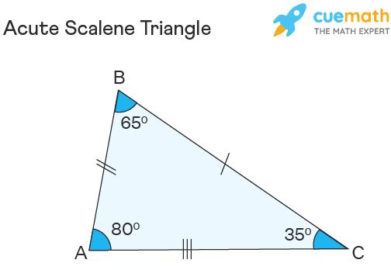
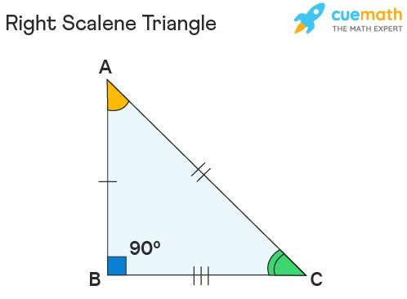
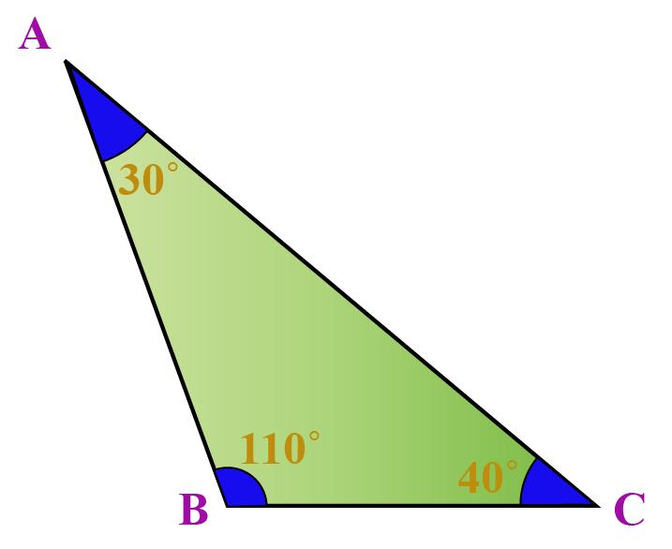
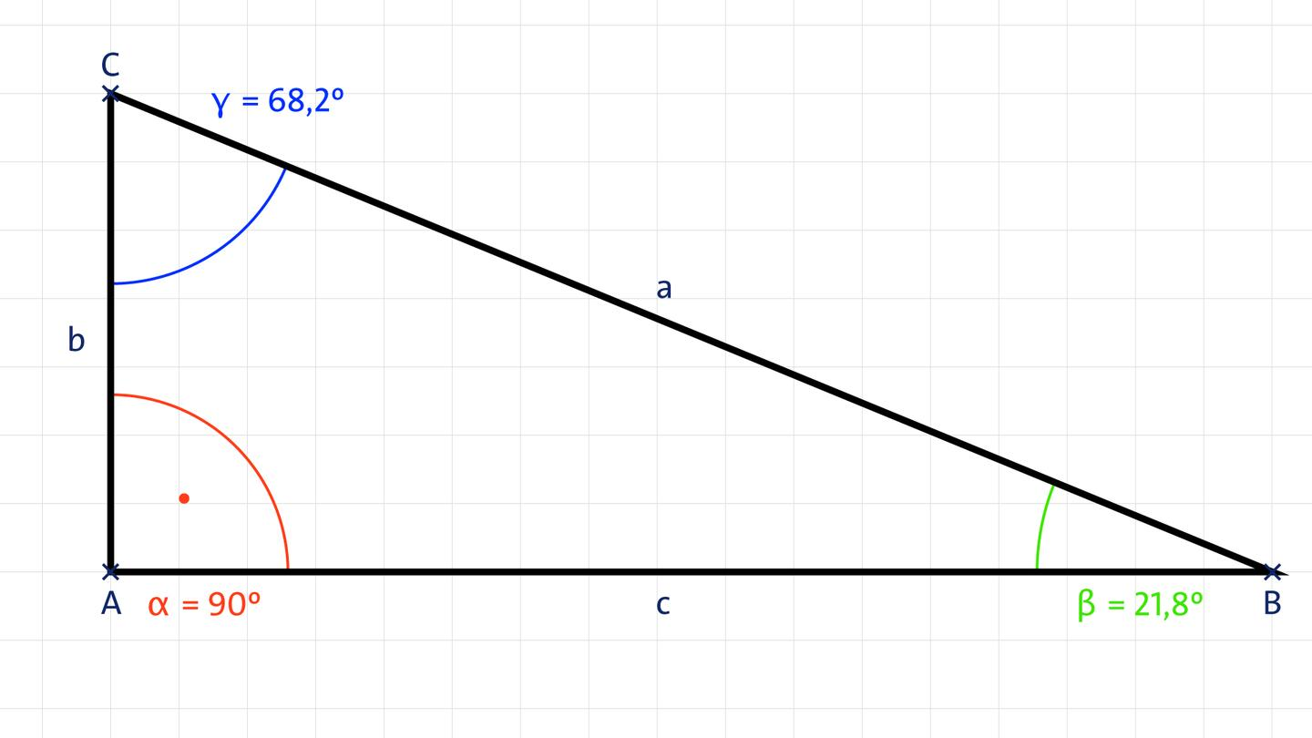
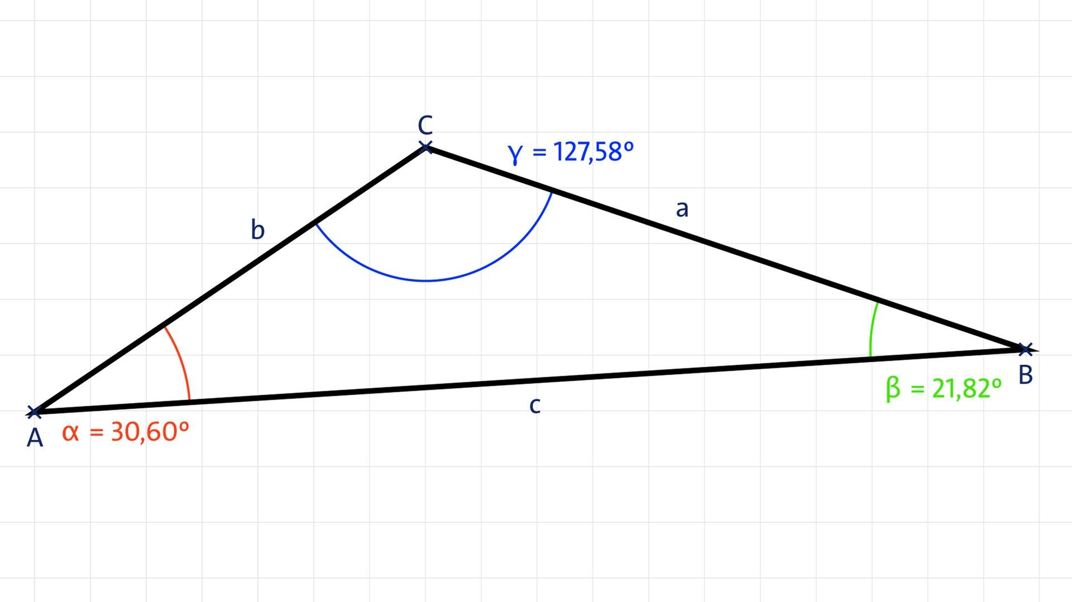

Right Scalene Triangle
# Source: AI Source: Provided by: [Data Path: Persons Table -> ID Column: 1, Name_En Column: Motasem Essam] -> From: [ChatGPT] on [7/25/2026]
A right scalene triangle is particularly important because it satisfies the Pythagorean theorem:
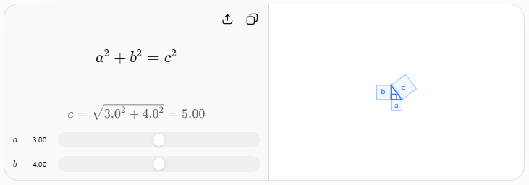
$$\boxed{a^{2}+b^{2}=c^{2}}$$
For example:
$$3^{2}+4^{2}=5^{2} \\ 9+16=25$$
so a $3$-$4$-$5$ triangle is a right scalene triangle.

Perimeter
# Source: AI Source: Provided by: [Data Path: Persons Table -> ID Column: 1, Name_En Column: Motasem Essam] -> From: [ChatGPT] on [7/25/2026]
For side lengths $a$, $b$, and $c$:
$$\boxed{P=a+b+c}$$
Unlike an equilateral triangle, the perimeter cannot generally be simplified to $3a$.

Area
# Source: AI Source: Provided by: [Data Path: Persons Table -> ID Column: 1, Name_En Column: Motasem Essam] -> From: [ChatGPT] on [7/25/2026]
The area can be calculated using the standard base-height formula:
$$\boxed{A=\frac{1}{2}bh}$$
where $b$is a chosen base and $h$is its corresponding altitude.
If only the three side lengths are known, Heron's Formula can be used:
$$\boxed{A=\sqrt{s\left(s-a\right)\left(s-b\right)\left(s-c\right)}}$$
where:
$$\boxed{s=\frac{a+b+c}{2}}$$

Example
# Source: AI Source: Provided by: [Data Path: Persons Table -> ID Column: 1, Name_En Column: Motasem Essam] -> From: [ChatGPT] on [7/25/2026]
Consider a triangle with side lengths:
$$a=5, b=6, c=7$$
Since:
$$5≠6, 6≠7, 7≠5$$
it is a scalene triangle.
Its semiperimeter is:
$$s=\frac{5+6+7}{2}=9$$
Using Heron's Formula:
$$A=\sqrt{9\left(9-5\right)\left(9-6\right)\left(9-7\right)} \\ A=\sqrt{216}$$
Therefore:
$$\boxed{A=6\sqrt{6}}$$
or approximately:
$$\boxed{A≈14.70}$$
square units.

Triangle Inequality
# Source: AI Source: Provided by: [Data Path: Persons Table -> ID Column: 1, Name_En Column: Motasem Essam] -> From: [ChatGPT] on [7/25/2026]
The three unequal side lengths must still satisfy the triangle inequality:
$$\boxed{a+b>c} \\ \boxed{a+c>b} \\ \boxed{b+c>a}$$
For $5,6,7$:
$$5+6>7 \\ 5+7>6 \\ 6+7>5$$
Therefore, these lengths can form a valid triangle.

Comparison with Other Triangle Types by Sides
# Source: AI Source: Provided by: [Data Path: Persons Table -> ID Column: 1, Name_En Column: Motasem Essam] -> From: [ChatGPT] on [7/25/2026]
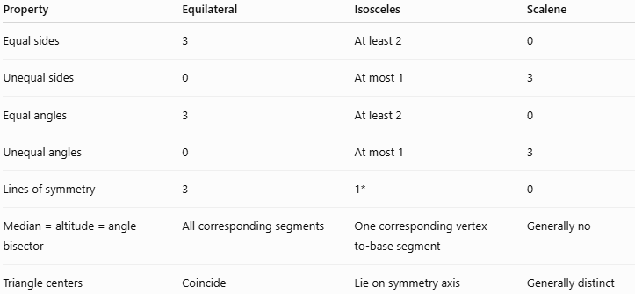
Property | Equilateral | Isosceles | Scalene
Equal sides | 3 | At least 2 | 0
Unequal sides | 0 | At most 1 | 3
Equal angles | 3 | At least 2 | 0
Unequal angles | 0 | At most 1 | 3
Lines of symmetry | 3 | 1* | 0
Median = altitude = angle bisector | All corresponding segments | One corresponding vertex-to-base segment | Generally no
Triangle centers | Coincide | Lie on symmetry axis | Generally distinct
(For a non-equilateral isosceles triangle.)

Relationship with Other Triangle Classifications
# Source: AI Source: Provided by: [Data Path: Persons Table -> ID Column: 1, Name_En Column: Motasem Essam] -> From: [ChatGPT] on [7/25/2026]
Classification by sides and classification by angles are independent classification systems.
Therefore, a scalene triangle can be:
$$\boxed{\text{Acute Scalene}} \\ \boxed{\text{Right Scalene}}$$
or:
$$\boxed{\text{Obtuse Scalene}}$$
For example:
$$\boxed{3-4-5=\text{Right Scalene Triangle}}$$

Real-World Applications
# Source: AI Source: Provided by: [Data Path: Persons Table -> ID Column: 1, Name_En Column: Motasem Essam] -> From: [ChatGPT] on [7/25/2026]
Scalene triangles occur naturally in:
- Land surveying.
- Irregular triangular plots.
- Engineering structures.
- Architecture.
- Geographic measurements.
- Computer graphics.
- Computer-aided design.
- Triangulation.
- Structural analysis.
They are especially common when three measured points do not have equal or symmetric spacing.

Important Formulas
# Source: AI Source: Provided by: [Data Path: Persons Table -> ID Column: 1, Name_En Column: Motasem Essam] -> From: [ChatGPT] on [7/25/2026]
Perimeter
$$\boxed{P=a+b+c}$$
Area
$$\boxed{A=\frac{1}{2}bh}$$
Heron's Formula
$$\boxed{A=\sqrt{s\left(s-a\right)\left(s-b\right)\left(s-c\right)}}$$
Semiperimeter
$$\boxed{s=\frac{a+b+c}{2}}$$
Right Scalene Triangle
If the triangle is right:
$$\boxed{a^{2}+b^{2}=c^{2}}$$

Taxonomy
# Source: AI Source: Provided by: [Data Path: Persons Table -> ID Column: 1, Name_En Column: Motasem Essam] -> From: [ChatGPT] on [7/25/2026]
For your knowledge base:
Plane Geometry
└── Triangles
└── Triangle Classification
└── Classification by Sides
├── Equilateral Triangle
├── Isosceles Triangle
└── Scalene Triangle
Angle-based subtypes can be organized independently:
Scalene Triangle
└── Classification by Angles
├── Acute Scalene Triangle
├── Right Scalene Triangle
└── Obtuse Scalene Triangle
This is preferable to mixing the two classification systems because "scalene" describes the sides, while "acute/right/obtuse" describes the angles.

Key Points
# Source: AI Source: Provided by: [Data Path: Persons Table -> ID Column: 1, Name_En Column: Motasem Essam] -> From: [ChatGPT] on [7/25/2026]
- A scalene triangle has three unequal sides:
$$\boxed{a≠b, b≠c, c≠a}$$
- It has three unequal angles.
- The largest side is opposite the largest angle.
- The smallest side is opposite the smallest angle.
- A scalene triangle has no line of reflection symmetry.
- Its medians, altitudes, and angle bisectors are generally distinct.
- It can be acute, right, or obtuse.
- A right scalene triangle satisfies:
$$\boxed{a^{2}+b^{2}=c^{2}}$$
- Heron's Formula can find its area when all three sides are known.

Conclusion
# Source: AI Source: Provided by: [Data Path: Persons Table -> ID Column: 1, Name_En Column: Motasem Essam] -> From: [ChatGPT] on [7/25/2026]
A scalene triangle is a triangle with three different side lengths and three different interior angles. Unlike equilateral and isosceles triangles, it has no reflection symmetry, and its medians, altitudes, and angle bisectors generally do not coincide. It can independently be classified as acute, right, or obtuse, making it the most general of the three basic side-based triangle classifications.

